**Classification of Military Mission Success Using Predictive Modelling.**

**Project Description**

Imagine you are an ML Engineer tasked with predicting the success of military missions. You have access to a dataset containing historical mission data, including variables such as terrain, weather conditions, force strength, and intelligence accuracy. Your goal is to analyze this data and develop a machine learning model that can predict whether a mission is likely to succeed or fail.

This project involves comprehensive data collection, meticulous feature selection, and the application of advanced modelling techniques. The objective is to provide military planners with actionable insights that allow for the pre-emptive identification of potential risks, ultimately enhancing strategic decision-making and mission preparedness. By integrating predictive analytics into the planning phase, you aim to optimize resource allocation, improve operational effectiveness, and increase the probability of mission success.

The outcomes of this project are expected to contribute significantly to the evolution of data-driven strategies in military operations, providing a robust framework for enhancing the effectiveness and success rates of complex missions.

**Scenario 1: Strategic Planning and Risk Management for Military Operations**

Military organizations often face challenges in predicting the success of complex missions due to variables such as weather, terrain, and intelligence reliability. Traditional planning methods have proven insufficient, leading to critical failures. The Classification of Military Mission Success Using Predictive Modelling project seeks to address these challenges by developing a machine learning model that predicts mission success. Integrating this model into the strategic planning process allows for data-driven adjustments to mission parameters, resulting in improved mission success rates and more effective resource allocation.

**Scenario 2: Real-time Decision Support for Commanders**

In high-stakes military operations, commanders require real-time insights to make informed decisions. The predictive model developed in this project can be integrated into decision support systems, providing commanders with real-time predictions on mission success. This enables them to make adjustments during the execution phase, optimizing strategies based on the latest data and reducing the risk of mission failure.

**Scenario 3: Resource Optimization and Operational Efficiency**

Effective resource allocation is critical for the success of military missions. By utilizing the predictive model, military organizations can optimize resource allocation based on the predicted success rates of different missions. This ensures that resources are directed towards missions with a higher probability of success, thereby maximizing operational efficiency and minimizing unnecessary risks.

**Technical Architecture**: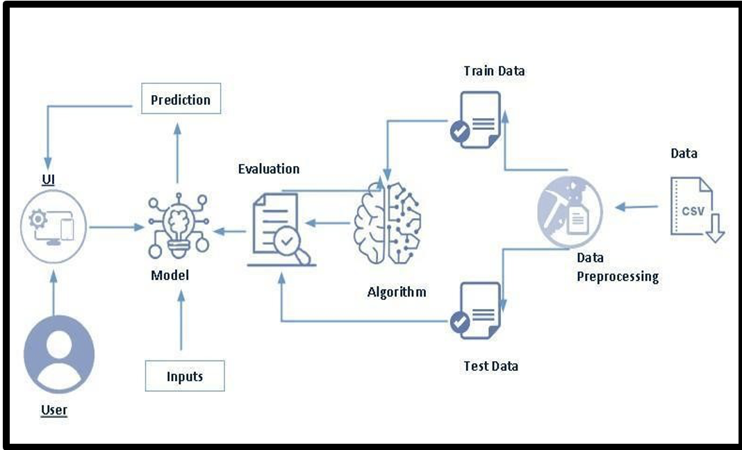

**Project Flow:**

* User interacts with the UI to enter the input.
* Entered input is analyzed by the model which is integrated.
* Once model analyses the input the prediction is showcased on the UI

**To accomplish this, we have to complete all the activities listed below:**

* **Data Collection & Preparation** 
  + Collect the dataset
  + Data Preparation
* **Exploratory Data Analysis** 
  + Descriptive statistical
  + Visual Analysis
* **Model Building** 
  + Training the model in multiple algorithms
  + Testing the model
* **Performance Testing** 
  + Testing model with multiple evaluation metrics
  + Comparing model accuracy
* **Model Deployment** 
  + Save the best model
  + Integrate with Web Framework

**Prior Knowledge:**

You must have the prior knowledge of the following topics to complete this project.

* ML Concepts:
* Supervised learning: [https://www.javatpoint.com/supervised-machine-learning](http://www.javatpoint.com/supervised-machine-learning)
* Logistic Regression: <https://www.geeksforgeeks.org/understanding-logistic-regression/>
* K Neighbors Classifier: <https://www.geeksforgeeks.org/k-nearest-neighbours/>
* Random Forest classifier: <https://www.geeksforgeeks.org/random-forest-classifier-using-scikit-learn/>
* Decision Tree Classifier: https://www.geeksforgeeks.org/decision-tree/
* Flask Basics: [https://www.youtube.com/watch?v=lj4I_CvBnt0](http://www.youtube.com/watch?v=lj4I_CvBnt0)

**Project Structure**

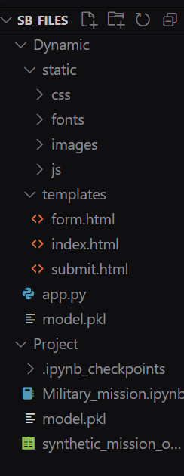

- We are building a Flask application that needs HTML pages stored in the Template folder and python script app.py for scripting

* Model.pkl is our saved model. Further, we will use this model for flask integration.
* Training folder contains a model training file.

**Milestone 1: Data Collection & Preparation**

ML depends heavily on data. It is the most crucial aspect that makes algorithm training possible. So, this section allows you to download the required dataset.

**Activity 1: Collect the Dataset**

There are many popular open sources for collecting the data. Eg: kaggle.com, UCI repository, etc. In this project we have used .csv data. This data is downloaded from kaggle.com. Please refer to the link given below to download the dataset.

Dataset: [LINK](https://drive.google.com/file/d/1HNOjU6byXXBkU88flN0_A2nvEJEf7CA3/view?usp=sharing)

As the dataset is downloaded. Let us read and understand the data properly with the help of some visualisation techniques and some analysing techniques.

**Note:** There are several techniques for understanding the data. But here we have used some of it. In an additional way, you can use multiple techniques.

**Activity 1.1: Importing the libraries**

Import the necessary libraries as shown in the image.

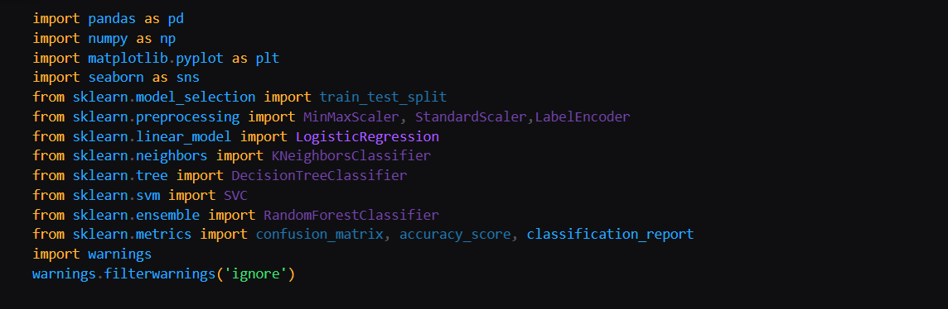

## Activity 1.2: Read the Data set

Our dataset format might be in .csv, excel files, .txt, .json, etc. We can read the dataset with the help of pandas. In pandas, we have a function called read_csv() to read the dataset. As a parameter, we have to give the directory of the csv file.

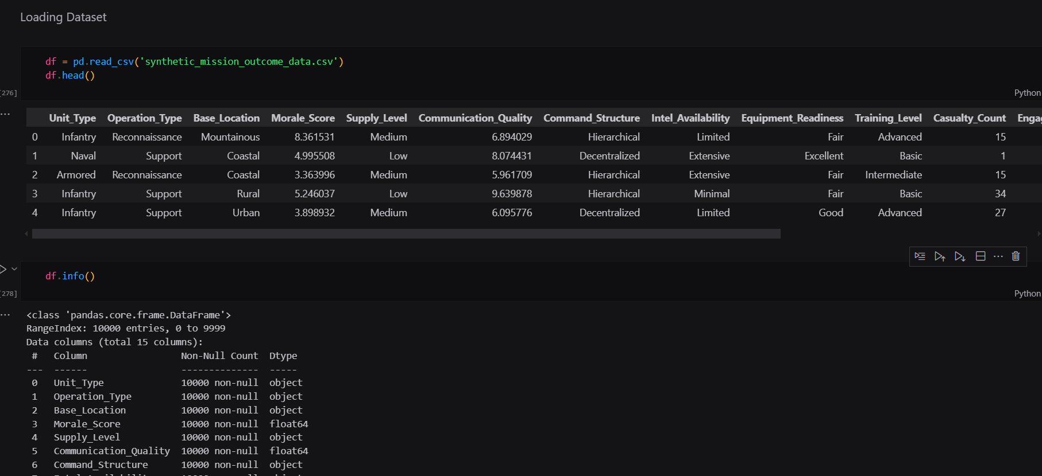

**Activity 2: Data Preparation**

As we have understood how the data is, let's pre-process the collected data.

The download data set is not suitable for training the machine learning model as it might have so much randomness and noise. So we need to clean the dataset properly in order to fetch good results.

This activity includes the following steps.

* Handling missing values
* Handling categorical data
* Handling Outliers

Note: These are the general steps of pre-processing the data before using it for machine learning. Depending on the condition of your dataset, you may or may not have to go through all these steps.

**Activity 2.1: Handling Missing Values**

Let’s find the shape of our dataset first. To find the shape of our data, the df. shape method is used. To find the data type, df.info () function is used.

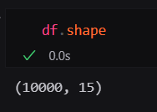

Above Figure Describes the Shape of the Dataset i.e, there are 958524 rows and 45 columns including the Target column as well.

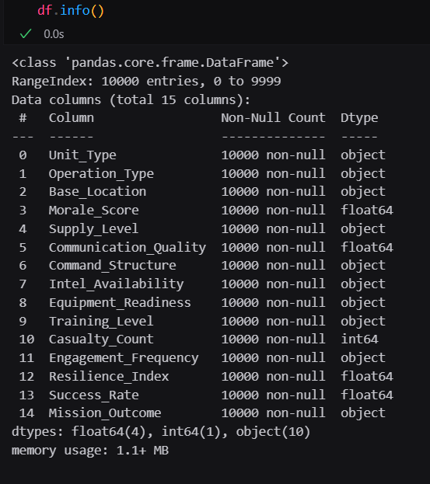

df.info() provides the information about the column’s datatype and provides the count of non-null values in the column.

For checking the null values, df.isnull() function is used. To sum those null values, we use .sum() function. By seeing the info figure we notice that there are some null values. To fill null values, we can use imputation or else we can use mean, median or mode.

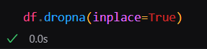

After filling null values, again we will check if there is any column containing null values.

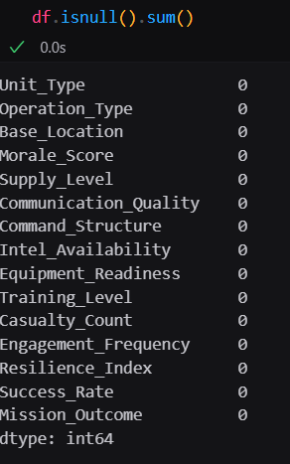

From the above figure, we can observe that there are no null values present in the dataset.

**Activity 2.2: Treating Outliers:**

Outliers are the abnormal data that are away from the range of the distribution of the data of each column in the data. Here we have the box plot to find whether the Outliers are present or not

in the data.

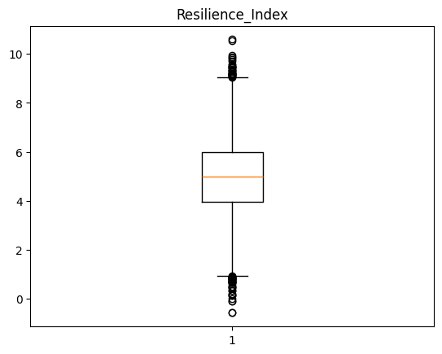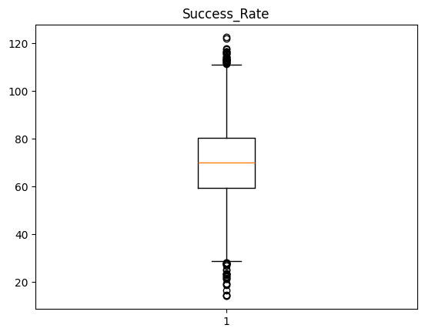

By seeing the above graphs we observe outliers for every column and the data is less to build the model so we treat the outliers as required and we will fit and transform the outlier data using IQR Technique.

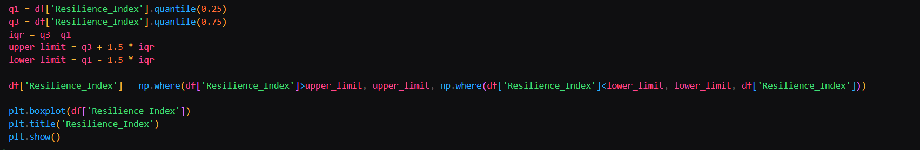

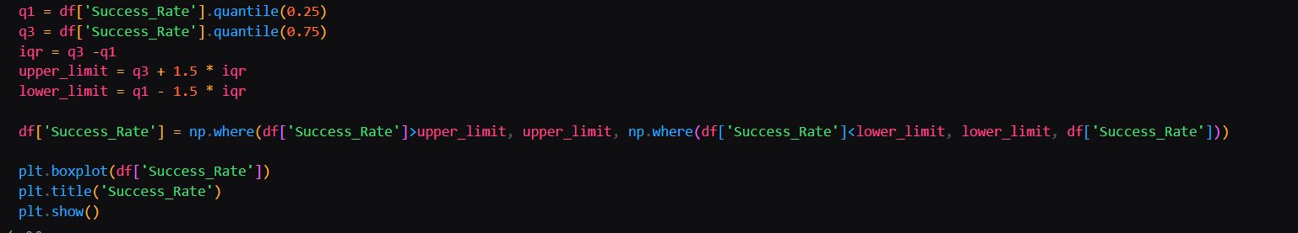

By the above snippet of above code we transformed the outlier data into the useful data.

**Milestone 2: Exploratory Data Analysis**

**Activity 1: Descriptive Analysis**

Descriptive analysis involves examining fundamental characteristics of data using statistical methods. It provides insights into the mean, standard deviation, minimum, maximum, and percentile values of continuous features.

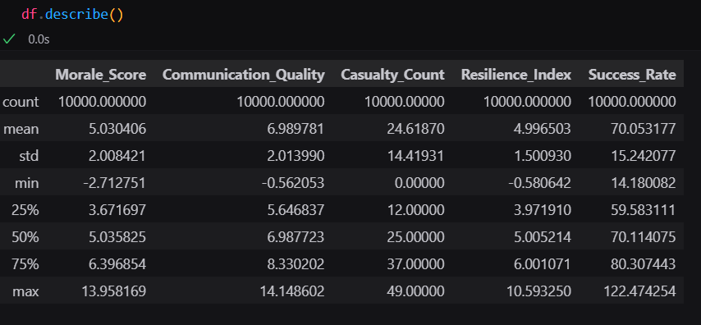

**Activity 2: Visual analysis**

Visual analysis is the process of using visual representations, such as charts, plots, and graphs, to explore and understand data. It is a way to quickly identify patterns, trends, and outliers in the data, which can help to gain insights and make informed decisions.

**Activity 2.1: univariate analysis**

In simple words, univariate analysis is understanding the data with a single feature. Here we have displayed a histogram, Pie chart, and Horizontal bar plot.

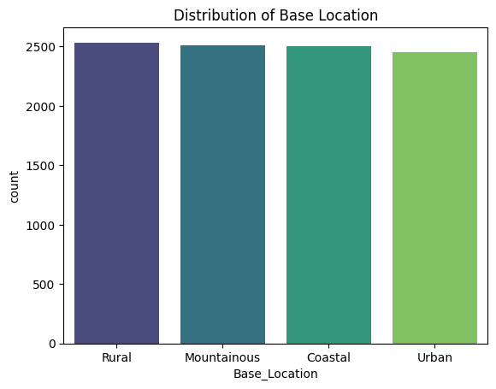

Interpretation: The bar chart displays the distribution of base locations. Coastal locations have the highest count, followed closely by mountainous and rural areas. Urban locations have a significantly lower count, and the number of unknown locations is minimal.

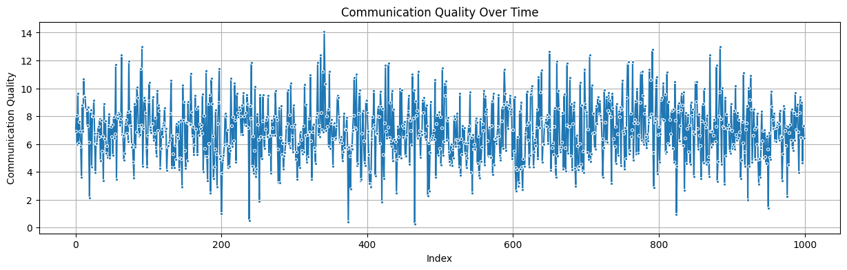

Interpretation: The line chart illustrates significant fluctuations in communication quality over time. Despite a potential scale ranging from 0 to 1000, the actual values remain consistently low, fluctuating between 0 and 10. This indicates a high degree of variability in communication quality with no discernible pattern. The data lacks a clear trend or predictability, suggesting inconsistent communication performance throughout the observed period.

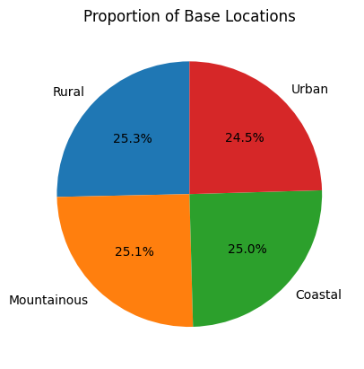

Interpretation: The pie chart illustrates the proportion of base locations in four categories: Rural, Urban, Mountainous, and Coastal. Each segment of the pie represents a category, with its size indicating the percentage of base locations in that category.Based on the chart, the distribution of base locations is relatively balanced, with each category accounting for approximately 25% of the total. This suggests that the bases are spread across various geographic regions, ensuring a diverse representation and potentially mitigating risks associated with concentration in a single area.

**Activity 2.2: Bivariate analysis**

Bivariate analysis is a statistical method that involves the analysis of two variables to determine the empirical relationship between them. Here we have Bar plots for Bivariate Analysis.

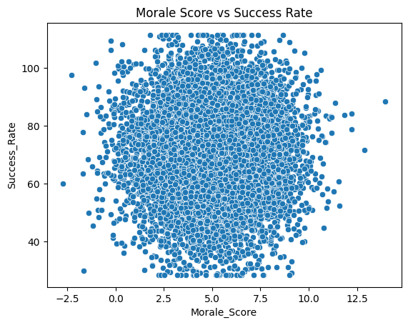

Interpretation: The analysis of the scatter plot revealed a complex relationship between morale and success. While there was no strong linear correlation, clustering and outliers suggested that factors beyond morale may influence success rates. The findings challenge the assumption that high morale is a guaranteed predictor of success, emphasizing the importance of considering other factors such as team dynamics, resources, and external circumstances.

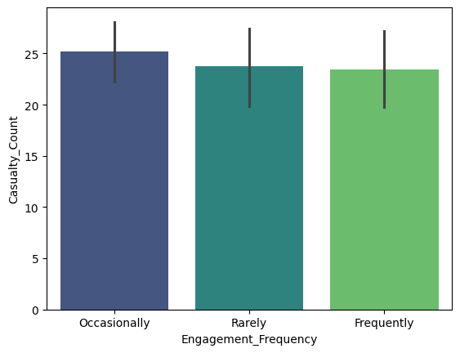

Interpretation: The graph illustrates a positive correlation between engagement frequency and casualty count. Higher engagement frequency is associated with a greater average number of casualties. However, the variability in casualty count is higher for less frequent engagements.

**Activity 2.3: Multivariate analysis**

Multi-variate analysis is a statistical method that involves the analysis of more than 2 variables to determine the empirical relationship among them. Here we have a heatmap representing the correlation among the variables in the Data.

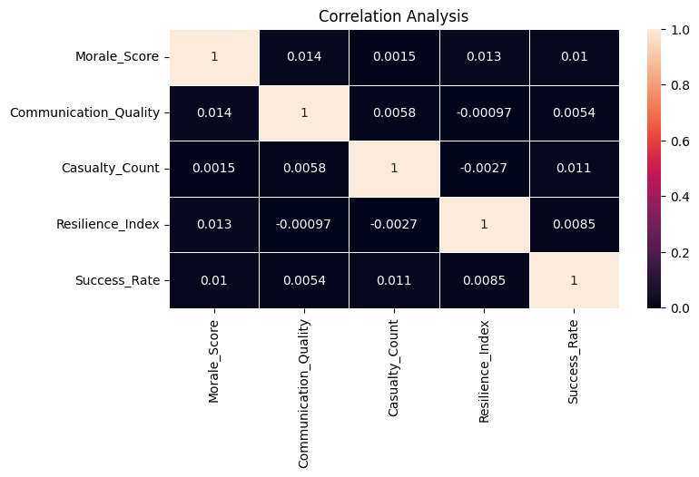

Interpretation: The correlation matrix reveals negligible relationships between variables. Morale Score, Communication Quality, Casualty Count, Resilience Index, and Success Rate exhibit minimal correlation with each other, suggesting independent influences on the overall outcome.

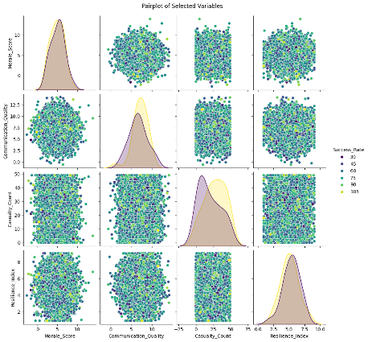

The pairplot reveals that Morale_Score and Casualty_Count are skewed, while Communication_Quality and Resilience_Index are normally distributed. Scatter plots show correlations between variables, suggesting that higher morale might be linked to better communication and lower casualty counts, and that better communication might be associated with higher resilience. The color coding based on Success_Rate might also reveal patterns. Overall, the pairplot offers a comprehensive understanding of the relationships between the variables.

**Activity 3: Splitting data into train and test**

Now let’s split the Dataset into train and test sets. First, split the dataset into x and y and then split the data set. “x” represents the whole data columns other than the target column,“y” represents the Target column in the dataset. We need to build the model by giving the training to the model and making the predictions on the test data.so we need to divide the whole dataset into training and testing data.

For splitting training and testing data we are using train_test_split () function from sklearn. As parameters, we are passing x, y, test_size, random_state.

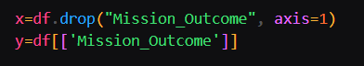



**Milestone 3: Model Building**

**Activity 1: Training and testing the models using multiple algorithms**

Now our data is cleaned and it’s time to build the model. We can train our data on different algorithms. For this project, we are applying classification algorithms. The best model is saved based on its performance.

**Activity 2: Model Building**

**Activity 2.1: Logistic Regression:**

Logistic Regression is the baseline model where we import the Logistic Regression from the sklearn library and import the linear_model and assign the model to the variable model1 and make the data fit and processing the data with respect to the training data.

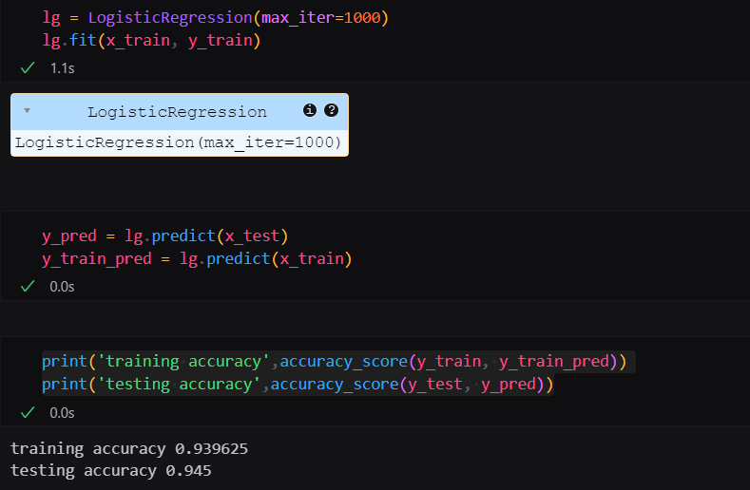

We make the predictions on the train and test data using predict function and assigning the predicted values to the y_pred_train and y_pred_test

We are calculating the accuracy scores on how the model is working on the data and by applying this model it is noticed that the model is underfitted.

From the Logistic Regression model, we got train accuracy as 0.939625 and test accuracy as 0.945.

**Activity 2.2: KNeighbors Classifier:**

KNeighbors Classifier algorithm is initialized and the training data is passed to the model and assigned the variable as model2 with the .fit() function. Test data is predicted with model2.predict() function and saved in a new variable. For evaluating the model, accuracy is calculated

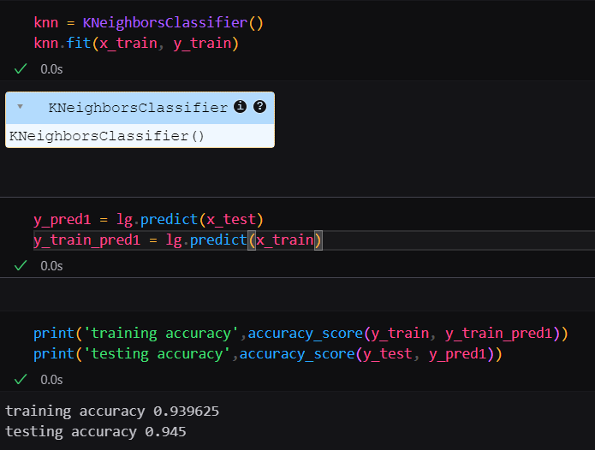

We have built a model and assigned to a variable knn, making predictions, finding accuracy using the Build Model.

From the K Neighbors Classification model, we got train accuracy as 0.939625 and test accuracy as 0.945.

**Activity 2.3: Decision Tree Classifier:**

Decision Tree Classifier and regression algorithm is initialized and the training data is passed to the model and assigned the variable as model3 with the .fit() function. Test data is predicted with model3.predict() function and saved in a new variable. For evaluating the model, accuracy is calculated

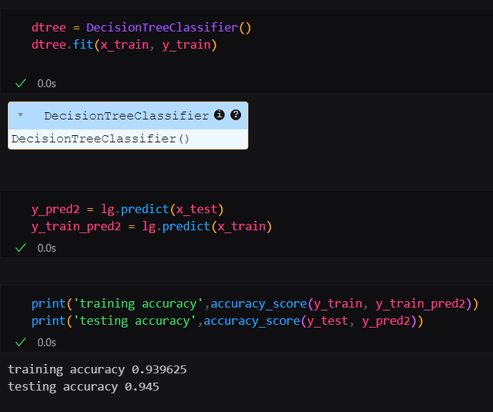

At the end we need to observe the train accuracy is less than test accuracy and it caused due to the underfitted model such models cannot predict the accurate results.

## Activity 2.4 : Random-Forest Classifier

Random Forest algorithm is the classification and regressions algorithm initialized and training data is passed to the model and assigned to the variable as model4 with .fit() function. Test data is predicted with model4.predict() function and saved in a new variable. For evaluating the model accuracy is calculated. For the best obtaining of accuracy we use hyper parameter tuning to tune the model with the best hyper parameters using the Grid Search CV by choosing the best params we can able to get the best accuracy this method is known as Hyper parameter Tuning.

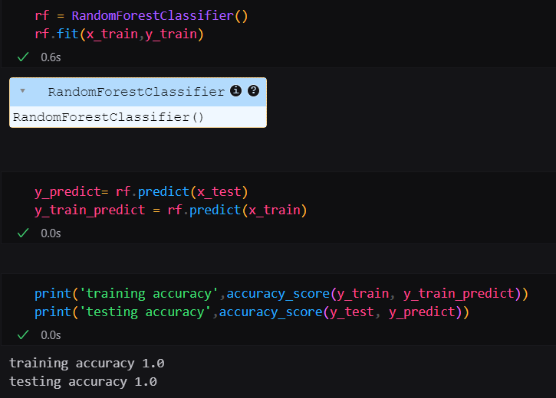

From the Random Forest Classifier model, we got train accuracy as 1.0 and test accuracy as 1.0.

**Milestone 4: Performance Testing**

Under performance Testing we need to test the model’s accuracy with different testing Metrics like Precision, Recall and F1_score. Below are the performance Metrics of final fixed model

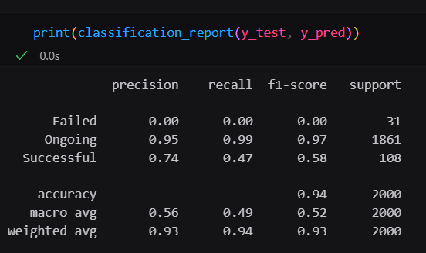

By doing Performance Testing, we got precision value as 0.93, recall value as 0.94 and f1_score as 0.93.

# **Milestone 5: Model Deployment**

# **Activity 1: Save and load the best model**

Saving the best model after comparing its performance using different evaluation metrics means selecting the model with the highest performance. This can be useful in avoiding the need to retrain the model every time it is needed and also to be able to use it in the future.

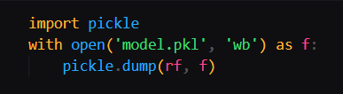

## Activity 2 : Test the model

Let’s test the model first in python notebook itself. As we have 7 features in this model, let’s check the output by giving all the inputs.

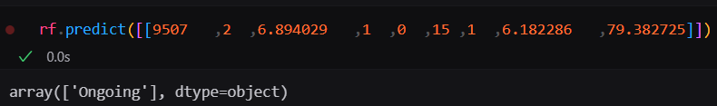

The predicted value and actual value are results same.

**Activity 3: Integrate with Web Framework**

In this section, we will be building a web application that is integrated to the model we built. A UI is provided for the uses where he has to enter the values for predictions. The enter values are given to the saved model and prediction is showcased on the UI.

This section has the following tasks

* Building HTML Pages
* Building server-side script
* Run the web application

**Activity 3.1: Building Html Pages:**

For this project create two HTML files namely

* index.html
* predict.html
* result.html

and save them in the templates folder.

**Activity 3.2: Build Python code:**

Import the libraries

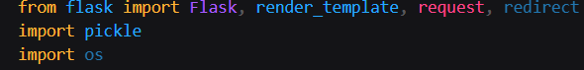

Load the saved model. Importing the flask module in the project is mandatory. An object of Flask class is our WSGI application. Flask constructor takes the name of the current module (__name__) as argument.

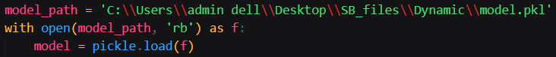

We render index.html for the displaying the web application , similarly we render the predict.html for the user input values of the forms to predict the income. Simultaneously we render result .html to display the result of the prediction value.

Render Index.html:

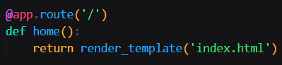

Here we will be using a declared constructor to route to the HTML page which we have created earlier.

In the above example, ‘/’ URL is bound with the index.html function. Hence, when the home page of the web server is opened in the browser, the html page will be rendered.

Render Predict.html:

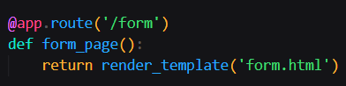

In the predict.html where we provide the user inputs in the form for the prediction of income

Whenever you enter the values from the html page the values can be retrieved using POST and GET Methods.

Retrieving the value from UI:

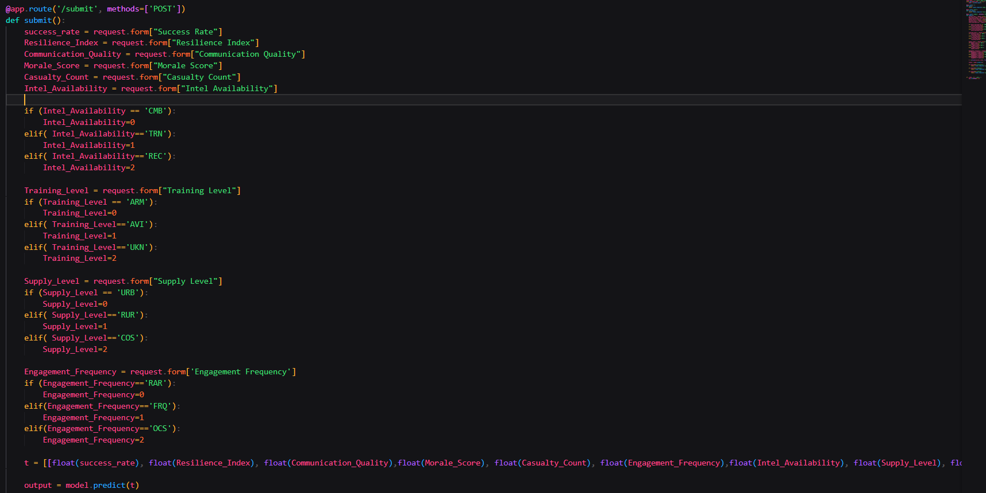

Here we are routing our app to conditional statement. This will retrieve all the values from the HTML page using Post request. That is stored in an array. This array is passed to the model.predict() function. This function returns the prediction. And this prediction value will be rendered to the text that we have mentioned in the submit.html page earlier.

Main Function:

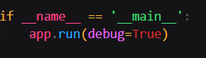

**Activity 3.3: Run the web application**

* Open vs code application in the search menu.
* Navigate to the folder where your flask folder of your files exist.
* Click on the view button in the vs code nav bar and click on the terminal option in the dropdown menu.
* Now type “app.py” command
* You will have a link displayed in the terminal as “<http://127.0.0.1:5000> “.
* Double click on the link then you will be navigated to the web application.
* Click on the predict button in the nav bar, enter the inputs, click on the predict button, and see the result/prediction in the result.html.

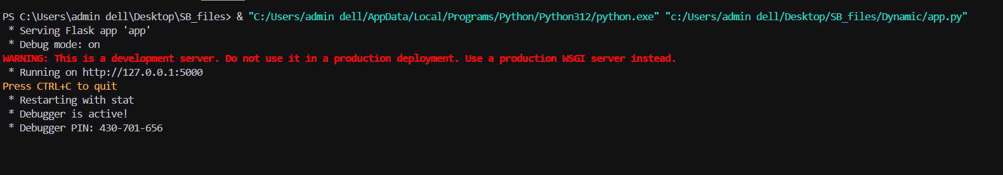

Now, Go the web browser and write the localhost URL (http://127.0.0.1:5000) to get the below results

Results:

1. Index page (Index.html)





If you click on the Get Started on the nav bar we can able to navigate to form.html below figure represents the UI of form.html page

b) Prediction page (form.html) and result page(submit.html)

i)

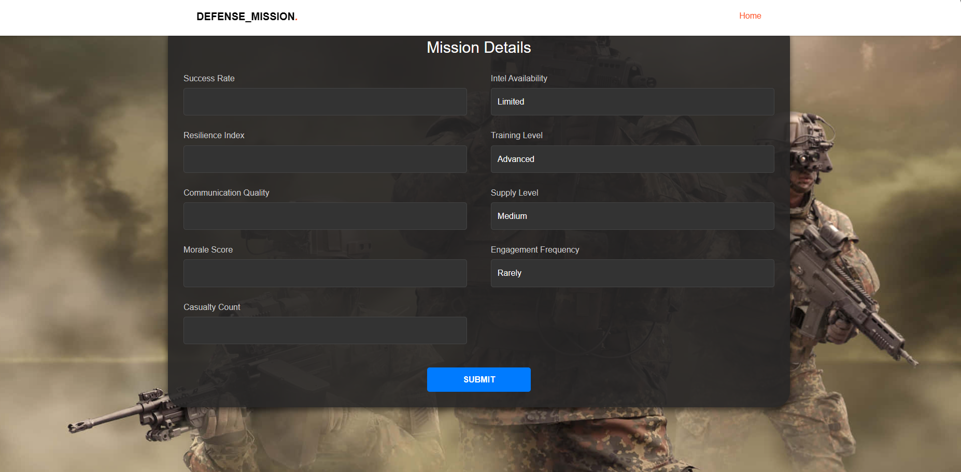

By providing,the inputs for the columns in the prediction page we will get the desired output in submit page.

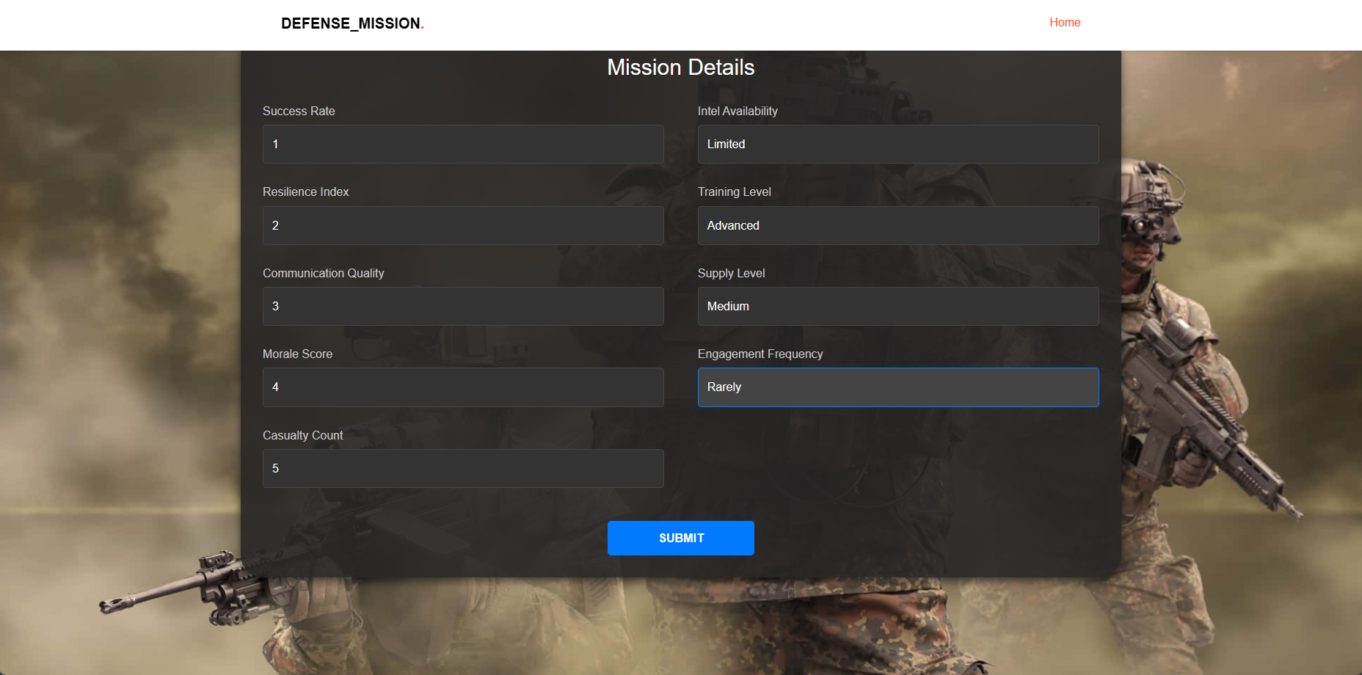

ii)

Similarly, we got the output for the other inputs given by user.



